

—------- FINAL PROJECT REPORT —-------
Modeling the Impact of Promotions on
Consumer Spending Behavior
Course: MAX 526 / MSC 651 – Quantitative Models
for Marketing

Instructor: Dr. Dinakar Jayarajan

Group #3:
Akshada Pawar
Srishti Gossain
Sai Seetal Pendyala
Barbie Jindal
Rudra More
Tanushre Kasandra Thirumal Rao

Contents

Problem Background 3
Data Description 3
Methodology 4
Model Analysis and Key Findings 5
Approach 1: Incremental Regression Models 5
Elasticity 6
Approach 2: Consolidated Models (Promotion vs. Non-Promotion) 7
Elasticity 8
Key Recommendations 9
Conclusion 10
Appendix 11

Problem Background
This project analyzes retail transaction data from an apparel and accessories brand that frequently uses discounts, promo codes, and shipping offers to drive sales. Management is concerned that promotions may be reducing margins without meaningfully increasing purchase value. They also lack clarity on which customer segments - by age, gender, and subscription status respond most to promotional incentives.
Goal:
Evaluate how promotional tactics influence purchase amount, estimate promotion elasticity, and determine whether promotions generate meaningful revenue lift.
Key Managerial Questions:
- Do discounts, promo codes, and shipping offers increase purchase amount?
- Which segments are more or less responsive to promotions?
- Are promotions creating incremental revenue or simply attracting deal-seekers?
- How should the firm design profitability-focused promotional strategies?

Data Description
The dataset includes anonymized transaction-level data from an online U.S. apparel and accessories retailer. The data spans multiple product categories and captures customer demographics, purchasing behavior, and marketing factors.
Data Structure: Each row represents a single purchase and includes:
- Purchase Details: Purchase Amount, Category, Season
- Promotional Variables: Discount applied, Promo Code Used, Shipping Type, Subscription status
- Customer Demographics: Age, Gender
- Customer Behavior: Previous Purchases, Review Rating
- Shopping Frequency Indicators: Annually, Biweekly, Every 3 Months, Fortnightly, Quarterly, Weekly
Key Descriptive Insights
- Average Purchase Amount: $59.76
- Promo Code Used: 43% of transactions
- Subscribers: 27%
- Average Age: 44
- Male: 68%
These descriptive patterns indicate a stable and loyal customer base with consistent spending behavior.

Methodology
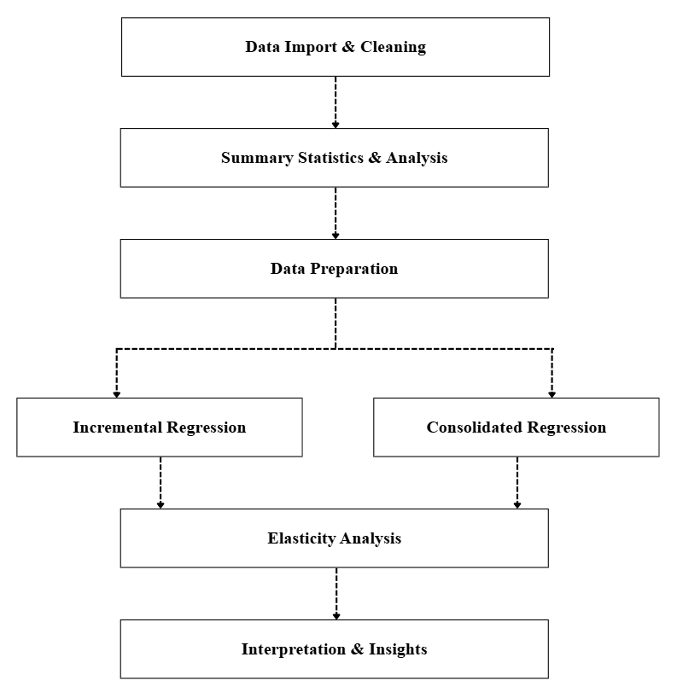
This project uses multiple linear regression (OLS) to measure how promotions, customer traits, and behaviors affect Purchase Amount (USD). OLS is chosen for its interpretability and ability to isolate each variable’s effect.
Exploratory Analysis:
PROC MEANS (Purchase Amount, Age), PROC FREQ (discounts, promo codes, shipping, gender, subscription), and PROC TABULATE (promotion–shipping patterns) were used to understand baseline trends.
Data Preparation:
All categorical variables were dummy-coded with baselines (Standard shipping, Accessories, Fall, Monthly frequency). Binary fields (Discount, Promo Code, Subscription, Gender) were converted to 0/1.
Incremental Modeling:
A stepwise series of regressions added predictors in stages - Promotions → Shipping → Subscription → Demographics → Category/Season → Behavioral variables → Full Model. This shows how explanatory power changes as more information is added.
Consolidated Models:
Two summary models were estimated:
Promotion-Only Model (discount, promo code, shipping)
Non-Promotion Model (demographics, categories, seasons, behaviors)
Elasticity:
Elasticities translate regression coefficients into practical changes in spending.

Model Analysis and Key Findings
To understand what truly drives purchase amount, we applied two structured modeling approaches. These approaches allowed us to isolate promotional effects, compare them to customer and behavioral factors, and observe how the model changes as new information is added.

Approach 1: Incremental Regression Models
This approach evaluates a sequence of eight regression models predicting Purchase Amount (USD). Each model adds a new set of variables, including promotions, demographics, category indicators, seasonal patterns, and behavioral factors, to understand their marginal contribution and improve interpretability.
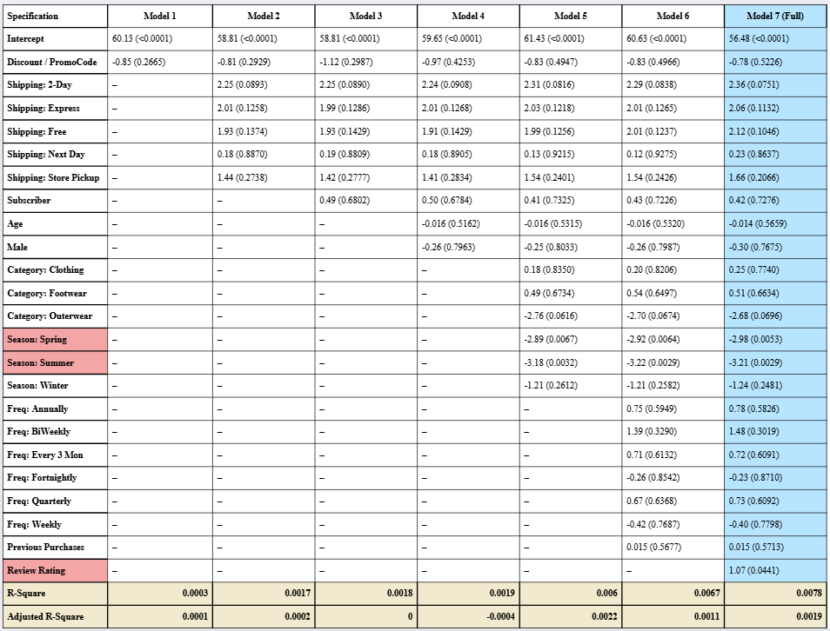
Model Interpretation:
Across all eight regression models, promotional variables - discounts, promo codes, and shipping types show only very small and statistically insignificant effects on purchase amount. Model fit remains extremely low throughout, with the full model explaining less than 1% (R² = 0.0061) of spending variation. This indicates that the customer purchase amount is highly stable and largely unaffected by promotions.
Adding additional predictors (subscription status, demographics, product category, season, frequency, previous purchases) only marginally improves explanatory power. In the full model, the only consistently significant variables are:
- Review Rating: Higher ratings slightly increase spending.
- Season (Spring & Summer): These months show slightly lower purchase amounts.
Everything else, shipping choices, discounts, promo codes, age, gender, subscription status, category differences, and shopping frequency, has a weak or no significant impact.
Key Insights:
- Promotions do not increase purchase value in any meaningful way.
- Shipping preferences show minimal influence on spending.
- Demographics do not drive purchase amounts.
- Seasonal dips occur in Spring and Summer, but the effect is small.
- Product categories differ only slightly; Outerwear trends lower.
- Behavioral factors (frequency, previous purchases) add almost no predictive power.

Elasticity
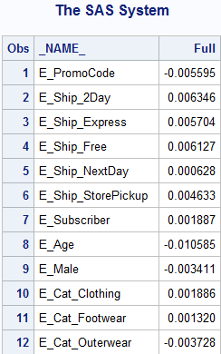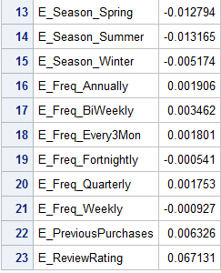
The incremental full model shows that the purchase amount is highly inelastic across almost all variables.
Most elasticities are close to zero, meaning that changes in promotions, demographics, product category, season, or shopping behavior lead to minimal proportional changes in spending. The only variable with a meaningful effect is Review Rating.
Promotional elasticities such as PromoCode (–0.0056), Subscriber (0.0019), and all shipping types (0.0046 to 0.0063) are extremely small, confirming that promotional levers do not increase how much customers spend. Demographic elasticities for Age and Male are also near zero, showing minimal differences across customer groups.
Category and seasonal elasticities remain very low. Clothing, Footwear, and Outerwear show only small positive or negative values, while Spring, Summer, and Winter reflect slight seasonal dips in spending. Shopping frequency variables and Previous Purchases have limited influence, with only small positive effects.
Review Rating has the largest elasticity at 0.0671, indicating that customer satisfaction contributes the most to increasing purchase amounts, even though the effect remains modest overall.

Approach 2: Consolidated Models (Promotion vs. Non-Promotion)
To better understand what drives customer spending, two consolidated regression models were developed. The Promotion-Only Model focuses exclusively on promotional levers: promo codes, shipping upgrades, and subscription status to test whether these incentives meaningfully increase purchase value. The Non-Promotion Variables Model includes all remaining customer and product attributes, such as demographics, category, seasonality, review ratings, previous purchases, and shopping frequency, to evaluate how much of purchase behavior is driven by inherent customer or product characteristics rather than promotions.
Model Interpretation:
Promotion-Only Model:
Promotional levers, promo codes, shipping upgrades, and subscription status show no meaningful impact on purchase amount. The model’s explanatory power is extremely low (R² = 0.0018), and none of the promotional coefficients are statistically significant. Promo code users actually spend slightly less, and faster shipping options show only small, insignificant increases. Overall, customers spend roughly the same amount regardless of promotional engagement.
Non-Promotion Variables Model:
Including demographics, product category, seasonality, review ratings, and purchase behavior improves model fit only slightly (R² = 0.0061). Most variables remain insignificant, except:
- Seasonality: Spring (–$2.93) and Summer (–$3.21) show significantly lower spending than Fall.
- Review Rating: A small positive effect (+$1.05), suggesting higher satisfaction slightly increases spend.
Age, gender, category, frequency, and previous purchases do not meaningfully affect purchase value.

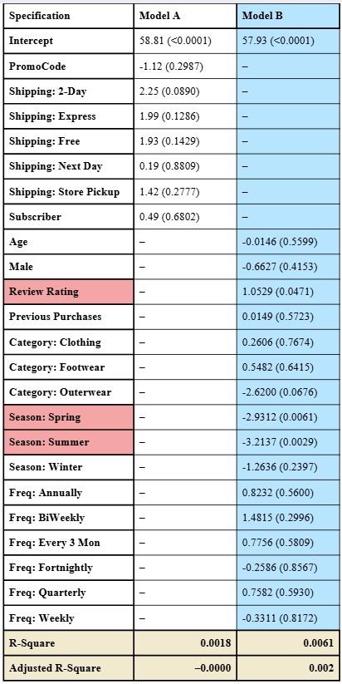

Elasticity
Promotion-Only Model
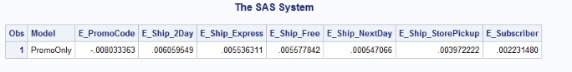
Across all models, the values are very close to zero, indicating extremely weak responsiveness.
- PromoCode elasticity (≈ –0.008): A 1% increase in promo code usage changes purchase amount by less than 0.01% → no meaningful financial impact.
- Shipping options (≈ 0.004–0.006): Minor positive elasticities show that different shipping methods barely influence basket value.
- Subscriber elasticity (≈ 0.002): Subscription status has negligible influence on spend per transaction.
Non-Promotion Model
- Demographics (Age, Gender): Elasticities near zero, indicating no demographic differences in spending behavior.
- Product attributes (Category, Season): Very small elasticities; seasonal or category preferences do not significantly shift purchase amount.
- Behavioral variables (Frequency, Previous Purchases): Minimal impact on spending; loyalty or purchase history does not increase basket size.
- Review Rating (≈ 0.067): The only variable with a slightly higher elasticity; better ratings modestly increase purchase amount, though the effect is still weak.
Overall Conclusion
Purchase amounts show very low sensitivity to promotions or customer characteristics, meaning none of these factors meaningfully increase spending. Managers should avoid blanket discounts and instead focus on improving product experience and using smarter, targeted promotional strategies.

Key Recommendations
Reduce Reliance on Promotions : Shift from broad promo codes and blanket discounts to targeted offers for price-sensitive segments. Reinvest promotional spend into loyalty, service, and retention programs.
Focus on Purchase Frequency, Not Basket Size : Prioritize repeat purchases through replenishment reminders, bundle incentives, email/SMS nudges, and loyalty rewards.
Improve Customer Satisfaction : Strengthen product quality, customer service, and post-purchase experience. Encourage and streamline product review submissions.
Plan for Seasonal Spending Declines : Reduce inventory and promo spend in warmer seasons. Redirect media and inventory planning toward Fall/Winter demand peaks.
Avoid Demographic Targeting : Replace demographic targeting with behavioral segmentation (engagement, browsing patterns, purchase history).
Optimize Product Mix Over Promotions : Promote higher-margin items and cross-selling (“complete the look”). Utilize curated bundles to increase units sold, rather than resorting to discounts.

Conclusion
The results of this analysis lead to a clear and actionable conclusion: customer purchase amount is extremely stable and largely unresponsive to promotional tactics or customer attributes. Across all models, promotional levers such as promo codes, discounts, shipping upgrades, and subscription status show no meaningful impact on basket size. This means the company’s current reliance on promotions is not increasing revenue and is likely reducing margins.
Non-promotional factors also add very little explanatory power. Demographics, product categories, purchase frequencies, and previous purchases do not significantly change how much customers spend. The only variables that show consistent effects are seasonality, where customers spend less in Spring and Summer, and product review ratings, where higher satisfaction is associated with slightly higher spending. Even these effects are modest.
Managerial Implications:
- Promotions are not an effective lever for increasing basket size, and continued use provides low return on investment.
- Revenue growth should focus on increasing the frequency of customer purchases rather than the amount spent per transaction.
- Seasonal demand patterns should guide inventory and media planning, especially in Fall and Winter when spending is naturally higher.
- Improvements in customer satisfaction and product quality are the only areas that show a measurable financial impact.
Overall, this analysis shows that the retailer’s revenue does not grow through bigger baskets, but through better customer experiences and repeated engagement. Customer spending remains steady regardless of promotional offers, making discount-heavy strategies inefficient and unproductive. A more effective path forward is to invest in loyalty, product satisfaction, and seasonally aligned planning. By focusing on what truly influences customer behavior, the company can build a more profitable and sustainable long-term strategy.

Appendix
LIBNAME shop 'C:\Users\PhotonUser\OneDrive - Illinois Institute of Technology\QMM Project';
PROC IMPORT DATAFILE = "C:\Users\PhotonUser\OneDrive - Illinois Institute of Technology\QMM Project\shopping_trends.csv"
OUT = shopping_trend DBMS = CSV REPLACE; RUN;
*INSPECT RAW DATA;
PROC PRINT DATA = shopping_trend (obs=10); RUN;
PROC CONTENTS DATA = shopping_trend; RUN;
*CLEAN DATA — DROP UNUSED VARIABLES;
data shoptrend_clean; set shopping_trend;
drop Customer_ID Item_Purchased Location Size Color Payment_Method Preferred_Payment_Method; Run;
proc contents data=shoptrend_clean; run;
proc print data=shoptrend_clean (obs=10); run;
PROC CONTENTS data=shoptrend_clean; run;
PROC PRINT DATA = shoptrend_clean (obs=10); RUN;
PROC FREQ DATA = shoptrend_clean; TABLE Shipping_Type; RUN;
PROC FREQ DATA = shoptrend_clean; Table Frequency_of_Purchases; RUN;
*Summary Statistics;
*Purchase Amount Distribution (Core Metric);
PROC MEANS DATA=shoptrend_clean MAXDEC=2; VAR Purchase_Amount__USD_; RUN;
*Promotion Usage Frequency (Discount, Promo Code, Shipping);
PROC FREQ DATA=shoptrend_clean; TABLE Discount_Applied Promo_Code_Used Shipping_Type; RUN;
*Segment-Wise Purchase Amount;
PROC MEANS DATA=shoptrend_clean MEAN MAXDEC=2; CLASS Discount_Applied; VAR Purchase_Amount__USD_; RUN;
PROC MEANS DATA=shoptrend_clean MEAN MAXDEC=2; CLASS Promo_Code_Used; VAR Purchase_Amount__USD_; RUN;
PROC MEANS DATA=shoptrend_clean MEAN MAXDEC=2; CLASS Shipping_Type; VAR Purchase_Amount__USD_; RUN;
*Demographic Patterns (Age, Gender, Subscription);
PROC MEANS DATA=shoptrend_clean; VAR Age; RUN;
PROC FREQ DATA=shoptrend_clean; TABLE Gender Subscription_Status; RUN;
*Category & Season Contribution to Spend;
PROC MEANS DATA=shoptrend_clean MEAN MAXDEC=2; CLASS Category; VAR Purchase_Amount__USD_; RUN;
PROC MEANS DATA=shoptrend_clean MEAN MAXDEC=2; CLASS Season; VAR Purchase_Amount__USD_; RUN;
*How Discount, Promo Code, and Shipping Type jointly affect Purchase Amount;
PROC TABULATE DATA=shoptrend_clean FORMAT=9.2; CLASS Discount_Applied Promo_Code_Used Shipping_Type; VAR Purchase_Amount__USD_;
TABLE (Discount_Applied ALL) * (Promo_Code_Used ALL) * (Shipping_Type ALL),(Purchase_Amount__USD_)*(N MEAN MEDIAN MIN MAX); RUN;
*DATA CLEANING & DUMMY VARIABLE CREATION;
DATA shoptrend_final; SET shoptrend_clean;
*1. Standardizing Promotion Variables;
IF Discount_Applied = "Yes" THEN Discount = 1; ELSE Discount = 0;
IF Promo_Code_Used = "Yes" THEN PromoCode = 1; ELSE PromoCode = 0;
IF Subscription_Status = "Yes" THEN Subscriber = 1; ELSE Subscriber = 0;
* 2. Gender Dummy Encoding;
IF Gender = "Male" THEN Male = 1; ELSE Male = 0;
* 3. Dummy Encoding: Shipping Type - Baseline = “Standard”;
Shipping_2Day = 0; Shipping_Express = 0; Shipping_Free = 0; Shipping_NextDay = 0; Shipping_StorePickup = 0;
IF Shipping_Type = "2-Day Shipping" THEN Shipping_2Day = 1; ELSE IF Shipping_Type = "Express" THEN Shipping_Express = 1;
ELSE IF Shipping_Type = "Free Shipping" THEN Shipping_Free = 1; ELSE IF Shipping_Type = "Next Day Air" THEN Shipping_NextDay = 1;
ELSE IF Shipping_Type = "Store Pickup" THEN Shipping_StorePickup = 1;
*4. Dummy Encoding for Category - Baseline: Accessories;
Category_Clothing = 0; Category_Footwear = 0; Category_Outerwear = 0;
IF Category = "Clothing" THEN Category_Clothing = 1; ELSE IF Category = "Footwear" THEN Category_Footwear = 1;
ELSE IF Category = "Outerwear" THEN Category_Outerwear = 1;
* Dummy Encoding for Season - Baseline: Fall ; Season_Spring = 0; Season_Summer = 0; Season_Winter = 0;
IF Season = "Spring" THEN Season_Spring = 1;ELSE IF Season = "Summer" THEN Season_Summer = 1;ELSE IF Season = "Winter" THEN Season_Winter = 1;
* 6. Dummy Encoding for Frequency_of_Purchases - Baseline: Monthly;
Freq_Annually = 0; Freq_BiWeekly = 0; Freq_Every3Mon = 0; Freq_Fortnightly = 0; Freq_Quarterly = 0; Freq_Weekly = 0;
IF Frequency_of_Purchases = "Annually" THEN Freq_Annually = 1; ELSE IF Frequency_of_Purchases = "Bi-Weekly" THEN Freq_BiWeekly = 1;
ELSE IF Frequency_of_Purchases = "Every 3 Mon" THEN Freq_Every3Mon = 1;ELSE IF Frequency_of_Purchases = "Fortnightly" THEN Freq_Fortnightly = 1;
ELSE IF Frequency_of_Purchases = "Quarterly" THEN Freq_Quarterly = 1; ELSE IF Frequency_of_Purchases = "Weekly" THEN Freq_Weekly = 1;
* 7. Drop the original text variables;
DROP Discount_Applied Promo_Code_Used Shipping_Type Subscription_Status Gender Category Season Frequency_of_Purchases; RUN;
PROC CONTENTS DATA=shoptrend_final; RUN;
PROC MEANS DATA=shoptrend_final N MEAN; RUN;
PROC PRINT DATA=shoptrend_final (OBS=10); RUN;
*REGRESSION ANALYSIS;
* APPROACH 1: INCREMENTAL REGRESSION MODELS;
proc reg data=shoptrend_final plots=none;
* Model 1: Promotions – Discount only;
* model Purchase_Amount__USD_ = Discount;
* Model 2: + Promo Code;
*model Purchase_Amount__USD_ = PromoCode;
* Model 3: + Shipping Type (baseline = Standard);
*model Purchase_Amount__USD_ = PromoCode Shipping_2Day Shipping_Express Shipping_Free Shipping_NextDay Shipping_StorePickup;
* Model 4: + Subscription Status;
*model Purchase_Amount__USD_ = PromoCode Shipping_2Day Shipping_Express Shipping_Free Shipping_NextDay Shipping_StorePickup Subscriber;
Model 5: + Demographics (Age, Gender);
*model Purchase_Amount__USD_ = PromoCode Shipping_2Day Shipping_Express Shipping_Free Shipping_NextDay Shipping_StorePickup Subscriber
Age Male;
* Model 6: + Category & Season (baseline: Accessories, Fall);
*model Purchase_Amount__USD_ = PromoCode Shipping_2Day Shipping_Express Shipping_Free Shipping_NextDay Shipping_StorePickup Subscriber
Age Male Category_Clothing Category_Footwear Category_Outerwear Season_Spring Season_Summer Season_Winter;
* Model 7: + Frequency of Purchases & Previous Purchases;
* model Purchase_Amount__USD_ = PromoCode Shipping_2Day Shipping_Express Shipping_Free Shipping_NextDay Shipping_StorePickup Subscriber
Age Male Category_Clothing Category_Footwear Category_Outerwear Season_Spring Season_Summer Season_Winter
Freq_Annually Freq_BiWeekly Freq_Every3Mon Freq_Fortnightly Freq_Quarterly Freq_Weekly Previous_Purchases;
* Model 8: Full model with all variables (add Review Rating);
*model Purchase_Amount__USD_ = PromoCode Shipping_2Day Shipping_Express Shipping_Free Shipping_NextDay Shipping_StorePickup Subscriber
Age Male Category_Clothing Category_Footwear Category_Outerwear Season_Spring Season_Summer Season_Winter
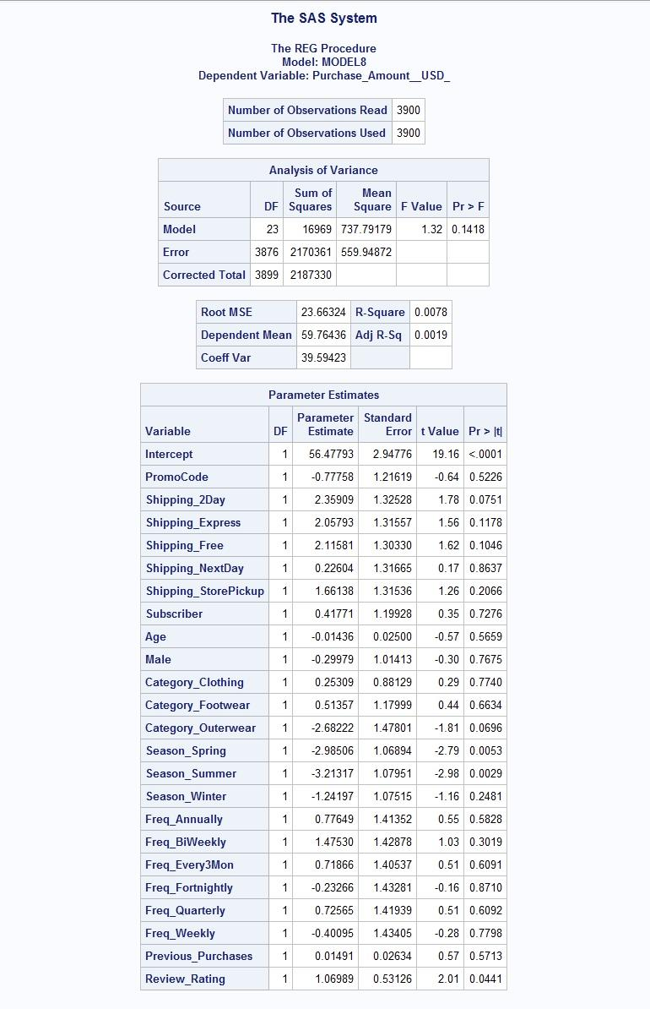
Freq_Annually Freq_BiWeekly Freq_Every3Mon Freq_Fortnightly Freq_Quarterly Freq_Weekly Previous_Purchases Review_Rating; run; Quit;

* APPROACH 1:
*Step 1: Regression model for elasticity:
proc reg data=shoptrend_final plots=none outest = est_increment_reg;
model Purchase_Amount__USD_ = PromoCode Shipping_2Day Shipping_Express Shipping_Free Shipping_NextDay Shipping_StorePickup
Subscriber Age Male Category_Clothing Category_Footwear Category_Outerwear Season_Spring Season_Summer Season_Winter
Freq_Annually Freq_BiWeekly Freq_Every3Mon Freq_Fortnightly Freq_Quarterly Freq_Weekly Previous_Purchases Review_Rating; run; quit;
*Step 2: Mean statistics for elasticity:
proc means data=shoptrend_final mean;
var Purchase_Amount__USD_ PromoCode Shipping_2Day Shipping_Express Shipping_Free Shipping_NextDay Shipping_StorePickup
Subscriber Age Male Category_Clothing Category_Footwear Category_Outerwear Season_Spring Season_Summer Season_Winter
Freq_Annually Freq_BiWeekly Freq_Every3Mon Freq_Fortnightly Freq_Quarterly Freq_Weekly Previous_Purchases Review_Rating ;
output out=means_full mean=/autoname; run;
*Elasticity calculations for incremental model;
data elasticity_full;
merge est_increment_reg(drop=_TYPE_) means_full(drop=_TYPE_);
length Model $10; Model = "Full";
YMean = Purchase_Amount__USD__Mean;
E_PromoCode = PromoCode * (PromoCode_Mean / YMean);
E_Ship_2Day = Shipping_2Day * (Shipping_2Day_Mean / YMean);
E_Ship_Express = Shipping_Express * (Shipping_Express_Mean / YMean);
E_Ship_Free = Shipping_Free * (Shipping_Free_Mean / YMean);
E_Ship_NextDay = Shipping_NextDay * (Shipping_NextDay_Mean / YMean);
E_Ship_StorePickup = Shipping_StorePickup * (Shipping_StorePickup_Mean / YMean);
E_Subscriber = Subscriber * (Subscriber_Mean / YMean);
E_Age = Age * (Age_Mean / YMean);
E_Male = Male * (Male_Mean / YMean);
E_Cat_Clothing = Category_Clothing * (Category_Clothing_Mean / YMean);
E_Cat_Footwear = Category_Footwear * (Category_Footwear_Mean / YMean);
E_Cat_Outerwear = Category_Outerwear * (Category_Outerwear_Mean / YMean);
E_Season_Spring = Season_Spring * (Season_Spring_Mean / YMean);
E_Season_Summer = Season_Summer * (Season_Summer_Mean / YMean);
E_Season_Winter = Season_Winter * (Season_Winter_Mean / YMean);
E_Freq_Annually = Freq_Annually * (Freq_Annually_Mean / YMean);
E_Freq_BiWeekly = Freq_BiWeekly * (Freq_BiWeekly_Mean / YMean);
E_Freq_Every3Mon = Freq_Every3Mon * (Freq_Every3Mon_Mean / YMean);
E_Freq_Fortnightly = Freq_Fortnightly * (Freq_Fortnightly_Mean / YMean);
E_Freq_Quarterly = Freq_Quarterly * (Freq_Quarterly_Mean / YMean);
E_Freq_Weekly = Freq_Weekly * (Freq_Weekly_Mean / YMean);
E_PreviousPurchases = Previous_Purchases * (Previous_Purchases_Mean / YMean);
E_ReviewRating = Review_Rating * (Review_Rating_Mean / YMean);
keep Model E_:; run;
* APPROACH 2 - PROMOTION-ONLY MODEL;
proc reg data=shoptrend_final plots=none;
model Purchase_Amount__USD_ = PromoCode Shipping_2Day Shipping_Express Shipping_Free Shipping_NextDay Shipping_StorePickup Subscriber; run; quit;
* APPROACH 2 - Non-Promotion Variables Model;
proc reg data=shoptrend_final plots=none;
model Purchase_Amount__USD_ = Age Male Review_Rating Previous_Purchases Category_Clothing Category_Footwear Category_Outerwear
Season_Spring Season_Summer Season_Winter Freq_Annually Freq_BiWeekly Freq_Every3Mon Freq_Fortnightly Freq_Quarterly Freq_Weekly; run; quit;
* APPROACH 2 - PROMOTION-ONLY MODEL;
*Step 1: Mean statistics for elasticity;
proc means data=shoptrend_final mean noprint;
var Purchase_Amount__USD_ PromoCode Shipping_2Day Shipping_Express Shipping_Free Shipping_NextDay Shipping_StorePickup Subscriber;
output out=means_promo mean=/autoname; run;
/* Step 2: Regression model (Promotion-Only) */
proc reg data=shoptrend_final plots=none outest=est_promo_only;
model Purchase_Amount__USD_ = PromoCode Shipping_2Day Shipping_Express Shipping_Free Shipping_NextDay Shipping_StorePickup Subscriber;run;quit;
/* Step 3: Elasticity Calculation */
data elasticity_promo; merge est_promo_only(drop=_TYPE_ _MODEL_)
means_promo(drop=_TYPE_ _FREQ_); length Model $20;
Model = "PromoOnly";
YMean = Purchase_Amount__USD__Mean;
E_PromoCode = PromoCode * (PromoCode_Mean / YMean);
E_Ship_2Day = Shipping_2Day * (Shipping_2Day_Mean / YMean);
E_Ship_Express = Shipping_Express * (Shipping_Express_Mean / YMean);
E_Ship_Free = Shipping_Free * (Shipping_Free_Mean / YMean);
E_Ship_NextDay = Shipping_NextDay * (Shipping_NextDay_Mean / YMean);
E_Ship_StorePickup = Shipping_StorePickup * (Shipping_StorePickup_Mean / YMean);
E_Subscriber = Subscriber * (Subscriber_Mean / YMean);
keep Model E_:; run;
proc print data=elasticity_promo; run;
*B. NON-PROMOTION MODEL;
/* Step 1: Mean statistics */
proc means data=shoptrend_final mean noprint;
var Purchase_Amount__USD_ Age Male Review_Rating Previous_Purchases Category_Clothing Category_Footwear Category_Outerwear
Season_Spring Season_Summer Season_Winter Freq_Annually Freq_BiWeekly Freq_Every3Mon Freq_Fortnightly Freq_Quarterly Freq_Weekly;
output out=means_nonpromo mean=/autoname; run;
/* Step 2: Regression model (Non-Promotion variables only) */
proc reg data=shoptrend_final plots=none outest=est_nonpromo;
model Purchase_Amount__USD_ = Age Male Review_Rating Previous_Purchases Category_Clothing Category_Footwear Category_Outerwear
Season_Spring Season_Summer Season_Winter Freq_Annually Freq_BiWeekly Freq_Every3Mon Freq_Fortnightly Freq_Quarterly Freq_Weekly; run; quit;
/* Step 3: Elasticity Calculation */
data elasticity_nonpromo; merge est_nonpromo(drop=_TYPE_ _MODEL_)
means_nonpromo(drop=_TYPE_ _FREQ_); length Model $20;
Model = "NonPromo";
YMean = Purchase_Amount__USD__Mean;
/* Continuous variables */
E_Age = Age * (Age_Mean / YMean);
E_Male = Male * (Male_Mean / YMean);
E_Review = Review_Rating * (Review_Rating_Mean / YMean);
E_PrevPurch = Previous_Purchases * (Previous_Purchases_Mean / YMean);
/* Category Dummies (baseline = Accessories) */
E_Cat_Cloth = Category_Clothing * (Category_Clothing_Mean / YMean);
E_Cat_Foot = Category_Footwear * (Category_Footwear_Mean / YMean);
E_Cat_Out = Category_Outerwear * (Category_Outerwear_Mean / YMean);
/* Season Dummies (baseline = Fall) */
E_Spring = Season_Spring * (Season_Spring_Mean / YMean);
E_Summer = Season_Summer * (Season_Summer_Mean / YMean);
E_Winter = Season_Winter * (Season_Winter_Mean / YMean);
/* Frequency Dummies (baseline = Monthly) */
E_Freq_Ann = Freq_Annually * (Freq_Annually_Mean / YMean);
E_Freq_BW = Freq_BiWeekly * (Freq_BiWeekly_Mean / YMean);
E_Freq_3Mon = Freq_Every3Mon * (Freq_Every3Mon_Mean / YMean);
E_Freq_Fort = Freq_Fortnightly * (Freq_Fortnightly_Mean / YMean);
E_Freq_Qtr = Freq_Quarterly * (Freq_Quarterly_Mean / YMean);
E_Freq_Week = Freq_Weekly * (Freq_Weekly_Mean / YMean);
keep Model E_:; run;
proc print data=elasticity_nonpromo; run;

